



**Location Studio** Qt Automotive Suite   
Runtime Environment Setup



June 2017

Revision Sheet

|  |  |  |
| --- | --- | --- |
| Release No. | Date | Revision Description |
| Rev. 0 | 6/13/17 | Initial Draft |
| Rev. 1 | 12/08/17 | Revised with x86 and ARM platforms |
|  |  |  |
|  |  |  |
|  |  |  |
|  |  |  |
|  |  |  |

**Table of Contents**

------------------------------------------------------------------------------------------------------------------------------

1. GENERAL INFORMATION 4

1.1 Purpose 5

1.2 Hardware and Software Requirements 5

1.3 Installation of software for ubuntu x64 development system 5

**1.3.1 OpenGL** 5

**1.3.2 Alsa sound libraries for TTS** 5

**1.3.3 Sqlite library** 5

**1.3.4 libphonon.so** 5

**1.3.5 freetype2** 6

**1.3.6 Install JRE 1.7 version.** 6

2. Set Up Environment 7

2.1 Set Up Environment for Ubuntu x86-64 7

2.1.1 Install Ubuntu-16.04.1 LTS 7

2.1.2 Download the Package 7

2.1.3 Run the install script 7

2.2 Set Up Environment for Intel NUC6i5SYH 8

2.2.1 Install toolchain with Qt license 8

2.2.2 Install Yocto image 8

2.2.3 Download the Package 9

2.2.4 Run the install script 9

2.3 Set Up Environment for Boundary Devices SABRE Lite iMX6 10

2.3.1 Install toolchain 10

2.3.2 Install Yocto image 10

2.3.3 Download the Package 11

2.3.4 Run the install script 11

3. Create Your Location Studio Developer Account and API Key 12

3.1 Create Your Developer Account 12

3.2 Add an Application 12

3.3 Create the API Key 13

4. Build the Application 14

4.1 Build application using sources from gitLab for Ubuntu x86-64 14

4.2 Build the application using sources from gitLab for Intel NUC6i5SYH 14

4.3 Build application using sources from gitLab for Boundary Devices SABRE Lite I.MX6 15

5. Run the Application 16

5.1 Run the Application on Ubuntu: 16

5.1.1 Adding API Key to the NeptuneUI Application: 16

5.1.2 Run the NeptuneUI: 16

5.1.3 Adding API Key to the LocationStudio reference app: 16

5.1.4 Run the LocationStudio reference app: 17

5.2 Run the Application on Intel-NUC: 17

5.2.1 Adding API key to the NeptuneUI Application: 17

5.2.2 Run the NeptuneUI: 18

5.3 Run the Application on Boundary Devices i.MX6: 18

5.3.1 Adding API key to the LocationStudio Reference Application: 18

5.3.2 Run the LocationStudio reference app: 18

# **GENERAL INFORMATION**

## Purpose

The purpose of this document is to provide the detailed information about the hardware and software environment settings and configurations needed to successfully load and run the Location Studio Automotive Reference application on various Linux platform for x86 -64, Intel NUC6i5YH and the Boundary Devices SABRE Lite I.MX6 hardware environment.

## Hardware and Software Requirements

| Name | Vendor, Model and Serial # |
| --- | --- |
| Device | 1. VMware player(>=6.0) or x86-64 motherboard 2. Intel NUC6i5SYH 3. Boundary Devices SABRE Lite I.MX6 |
| Operating System | 1. Ubuntu 16.04.01 LTS, x86, 64bit 2. Linux-yocto, x86_64 3. Linux-yocto, arm_32 |
| QT Version | 1. 5.9.2 |

## 

## Installation of software for ubuntu x64 development system

### **1.3.1 OpenGL**

Please install the OpenGL es2 library as follows:

$ sudo apt-get update

$ sudo apt install libgbm1 libegl1-mesa libegl1-mesa-drivers libgles2-mesa libgles2-mesa-dev libgl1-mesa-dri

### **1.3.2 Alsa sound libraries for TTS**

Please install the alsa sound library and alsa-oss library as follows:

$ sudo apt-get install libasound2-dev

$ sudo apt-get install alsa-oss

### **1.3.3 Sqlite library**

$ sudo apt-get install libsqlite3-dev

### **1.3.4 libphonon.so**

$ sudo apt-get install libphonon-dev

### **1.3.5 freetype2**

$ sudo apt-get install libfreetype6-dev

### **1.3.6 Install JRE 1.7 version.**

# **Set Up Environment**

# **Set Up Environment for Ubuntu x86-64**

## Install Ubuntu-16.04.1 LTS

Please follow the link below to download the image of ubuntu 16.04.1 LTS x86 64bit

PATH: <http://releases.ubuntu.com/12.04/ubuntu-12.04.4-desktop-i386.iso>.

This image can be either installed on Virtual Machine or actual x86-64 hardware platform.

## Download the Package

Download the package from <https://git.location.studio/location.studio/autoNavSDK> by either cloning it or downloading a zip file and uncompressing it. You may need to create an account on [https://git.location.studio](https://git.location.studio/) if you don’t already have one.

## Run the install script

$ sh install.sh all

Will install all dependency libraries, LocationStudio Qt Plugins, resources, Appmanager & Neptuneui

$ sh install.sh

Will install LocationStudio Qt Plugins, resources, Appmanager & Neptuneui without the dependencies.

# **Set Up Environment for Intel NUC6i5SYH**

## Install toolchain with Qt license

Please follow the link below to download the Qt Installer. Select the Intel NUC toolchain and install on /opt/Qt/Qt5.9.2:

PATH: <https://www.qt.io/download-qt-for-device-creation>

## Install Yocto image

The Qt prepared bootable yocto x86_64 image can be access:

From Qt Creator:

1. Bring up the “Boot to Qt Flashing Wizard” and select “Boot2Qt|Intel NUC|linux(Boot2Qt-5.9.2)  
   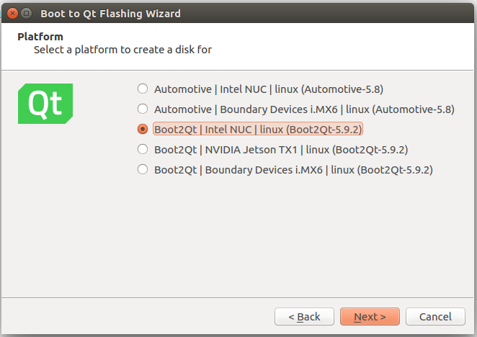
2. Select the target device for flashing the image.  
   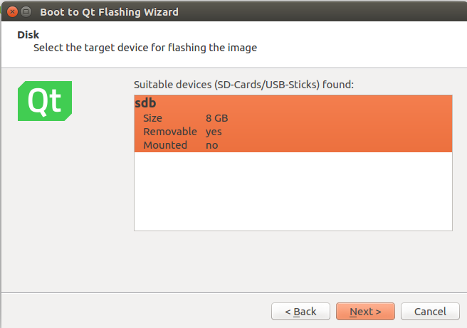

This image can be installed on actual hardware platform.

## Download the Package

Download the package from <https://git.location.studio/location.studio/autoNavSDK> by either cloning it or downloading a zip file and uncompressing it. You may need to create an account on [https://git.location.studio](https://git.location.studio/) if you don’t already have one.

## Run the install script

$ sh install.sh

Will install Qt5.9.2 Location Studio Qt Plugins, resources & appmanager.

# **Set Up Environment for Boundary Devices SABRE Lite iMX6**

## Install toolchain

Please follow the link below to download the Qt Installer. Select the Boundary Devices i.MX6 toolchain and install on /opt/Qt/Qt5.9.2:

PATH: <https://www.qt.io/download-qt-for-device-creation>

## Install Yocto image

The Qt prepared bootable yocto arm_32 image can be access:

From Qt Creator:

1. Bring up the “Boot to Qt Flashing Wizard” and select “Boot2Qt|Boundary Devices i.MX6|linux(Boot2Qt-5.9.2)  
   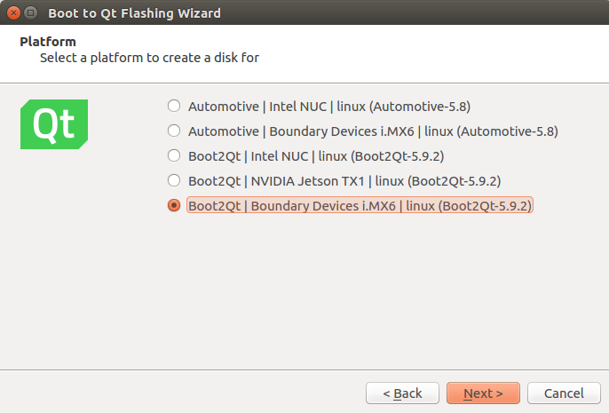
2. Select the target device for flashing the image.  
   

This image can be installed on actual hardware platform.

## Download the Package

Download the package from <https://git.location.studio/location.studio/autoNavSDK> by either cloning it or downloading a zip file and uncompressing it. You may need to create an account on [https://git.location.studio](https://git.location.studio/) if you don’t already have one.

## Run the install script

$ sh install.sh

Will install Qt5.9.2 Location Studio Qt Plugins, resources & appmanager.

# **Create Your Location Studio Developer Account and API Key**

## Create Your Developer Account

Create a developer account at <https://developer.location.studio/#/register>

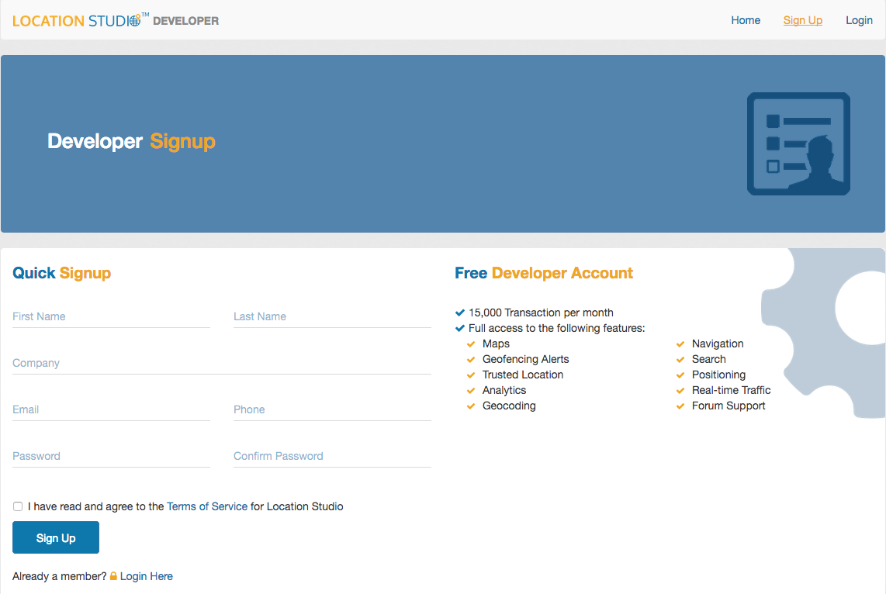

After creating the account, you will get an email to verify your email address. Please Verify your email to complete account creation.

## Add an Application

Go to <https://developer.location.studio/#/applications> and click ‘Add an Application’.



## Create the API Key

Specify the name of the application, select the “Search, Navigator and Mapping”

and click ‘Add’



The screen will refresh and you will now see your API key and Application name

displayed.



# **Build the Application**

# **Build application using sources from gitLab for Ubuntu x86-64**

Download source code: <https://github.com/GENIVI/navigation-next.git>

$ export PATH=/opt/Qt5.9.2/bin:$PATH

$ cd build/qt

$ sh build_ccc_ltk_qt_toolchain.sh –c –t ubuntu

Version string should be in version.txt.

$ cd <version string>

There should be a build package located here: ltk_<version string>_ubuntu_x86_64_hybrid.zip.

# **Build the application using sources from gitLab for Intel NUC6i5SYH**

Download source code: <https://github.com/GENIVI/navigation-next.git>

$ export PATH=/opt/Qt5.9.2/Boot2Qt/intel-corei7-64/toolchain/sysroots/x86_64-pokysdk-linux/usr/bin:$PATH

$ cd build/qt

$ sh build_ccc_ltk_qt_toolchain.sh –c –t nuc

Version string should be in version.txt.

$ cd <version string>

There should be a build package located here: ltk_<version string>_nuc_x86_64_hybrid.zip.

# **Build application using sources from gitLab for Boundary Devices SABRE Lite I.MX6**

Download source code: <https://github.com/GENIVI/navigation-next.git>

$ export PATH=/opt/Qt5.9.2/Boot2Qt/nitrogen6x/toolchain/sysroots/x86_64-pokysdk-linux/usr/bin:$PATH

$ cd build/qt

$ sh build_ccc_ltk_qt_toolchain.sh –c –t imx6

Version string should be in version.txt.

$ cd <version string>

There should be a build package located here: ltk_<version string>_imx6_arm_hybrid.zip.

# **Run the Application**

# **Run the Application on Ubuntu:**

This version of the app may be found under the tree /opt/locationstudio/neptuneui.

## Adding API Key to the NeptuneUI Application:

For the Neptune UI, add your API key to the files at the following location:

/opt/locationstudio/neptuneui/sysui/Cluster/Cluster.qml

/opt/locationstudio/neptuneui/sysui/Home/HomePage.qml

For Neptune, Cluster.qml is a much longer file. The relevant portion of Cluster.qml that needs to be modified with your API Key is:

ClusterView {

width: Style.clusterWidth - 50

zoom: 17.0

tilt: 15.0

client: "Neptune"

workFolder: "/opt/locationstudio/res/cluster"

token: "<**YOUR_APIKEY_HERE**>"

}

HomePage.qml is a much longer file as well. The relevant portion to modify is:

ConsoleView {

width: root.width/1.8

height: root.height

client: "Neptune"

workFolder: "/opt/locationstudio/res/console"

token: "<**YOUR_APIKEY_HERE**>"

}

## Run the NeptuneUI:

$ cd /opt/locationstudio/neptuneui

$ sh start.sh

## Adding API Key to the LocationStudio reference app:

Add your API key to the file at the following location: /opt/locationstudio/qtnavigator_sampleApp/resource/main.qml

The relevant portion of main.qml that needs to be modified with your API Key is:

ConsoleView {

id: consoleview

workFolder: "/opt/locationstudio/res/console"

width: parent.width

height: parent.height

isFollowMe: true

zoom: 17.0

tilt: 45.0

token: "<**YOUR_APIKEY_HERE**>"

}

## Run the LocationStudio reference app:

$ cd /opt/locationstudio/qtnavigator_sampleApp

$ sh start.sh

# **Run the Application on Intel-NUC:**

## Adding API key to the NeptuneUI Application:

For the Neptune UI, add your API key to the files at the following location:

/opt/locationstudio/neptuneui/sysui/Cluster/Cluster.qml

/opt/locationstudio/neptuneui/sysui/Home/HomePage.qml

For Neptune, Cluster.qml is a much longer file. The relevant portion of Cluster.qml that needs to be modified with your API Key is:

ClusterView {

width: Style.clusterWidth - 50

zoom: 17.0

tilt: 15.0

client: "Neptune"

workFolder: "/opt/locationstudio/res/cluster"

token: "<**YOUR_APIKEY_HERE**>"

}

HomePage.qml is a much longer file as well. The relevant portion to modify is:

ConsoleView {

width: root.width/1.8

height: root.height

client: "Neptune"

workFolder: "/opt/locationstudio/res/console"

token: "<**YOUR_APIKEY_HERE**>"

}

## Run the NeptuneUI:

To configure screen width & height, edit the following

Property at /opt/locationstuido/neptuneui/imports/shared/utils/Style.qml

Property int screenWidth

Property int screenHeight

Property int clusterWidth

Property int clusterHeight

$ cd /opt/locationstudio/neptuneui

$ sh start.sh

# **Run the Application on Boundary Devices i.MX6:**

## Adding API key to the LocationStudio Reference Application:

Add your API key to the file at the following location: /opt/locationstudio/qtnavigator_sampleApp/resource/main.qml

The relevant portion of main.qml that needs to be modified with your API Key is:

ConsoleView {

id: consoleview

workFolder: "/opt/locationstudio/res/console"

width: parent.width

height: parent.height

isFollowMe: true

zoom: 17.0

tilt: 45.0

token: "<**YOUR_APIKEY_HERE**>"

}

## Run the LocationStudio reference app:

$ cd /opt/locationstudio/qtnavigator_sampleApp

$ sh start.sh